Visvesvaraya Technological University, Belagavi, Karnataka – 590018
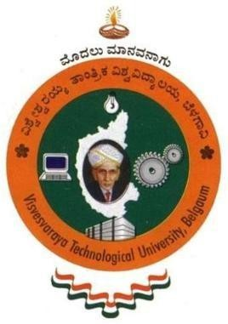

Mini - Project Report On
“MUSIC PLAYER”
Submitted in partial fulfilment of the requirements for the course
Web Technologies (MMC105)

Submitted by

Student Name: Ramitha R
USN: 1JS24MC023

Under the guidance of Mrs. Komala H S Assistant Professor, Dept. of MCA.


DEPARTMENT OF MASTER OF COMPUTER APPLICATION

JSS ACADEMY OF TECHNICAL EDUCATION
Dr. Vishnuvardhan road uttarahalli- kengeri main road,
Jss campus road, srinivaspura, Bengaluru, Karnataka 560060, india.

2024 – 2025

JSS Academy of Technical Education
JSS Campus, Dr. Vishnuvardhan road, Bengaluru – 560060
Department of Master of Computer Applications



CERTIFICATE

This is to certify that the Mini Project entitled “Music Player” is a bonafide work carried out by Ramitha R (1JS24MC023) in partial fulfillment of the requirements for the Mini Project of the 1st semester, Master of Computer Applications of Visvesvaraya Technological University, Belagavi, during the academic year 2024 – 2025. It is certified that all corrections and suggestions indicated for internal assessment have been incorporated in the report. The mini project report has been approved as it satisfies the academic requirements in respect of the project work prescribed for the said degree.

Mrs. Komala H S. Dr. Rohitaksha K.
Assistant Professor , Associate Professor and Head,
Dept. of MCA Dept of MCA
JSSATE, Bengaluru JSSATE, Bengaluru

ACKNOWLEDGEMENTS

I express my humble greetings to his holiness Jagadguru Sri Shivarathri Deshikendra Mahaswamijigalavaru who has showered their blessings on us for framing our career successfully.
I express my sincere thanks to our beloved principal, Dr. Bhimasen Soragaon for having supported us in our academic endeavors.
I am also grateful to Dr. Rohitaksha K, Associate professor, Head of the Department, Master of Computer Applications, for his unending support, guidance and encouragement in all our ventures.
I am thankful for the resourceful guidance, timely assistance and graceful gesture of my guide Mrs. Komala H S, Assistant Professor, Department of Master of Computer Applications, who helped me in every aspect of my Internship work.
Last, but not least, I am pleased to express our heart full thanks to all the teaching and non- teaching staff of the Department of Master of Computer Applications and my friends who have rendered their help, motivation, and support.

Name: Ramitha R
USN: 1JS24MC023

ABSTRACT

The "Music Player" is a web-based application that allows users to play music, manage playlists, and interact with various features related to song management. It includes functionalities like user registration, admin login, adding and deleting songs, and listening to songs online. The system leverages basic web technologies like HTML, CSS, JavaScript, and local storage for storing user information and music data. The application provides a seamless, user-friendly interface and is designed to be a reliable platform for managing and enjoying music.

